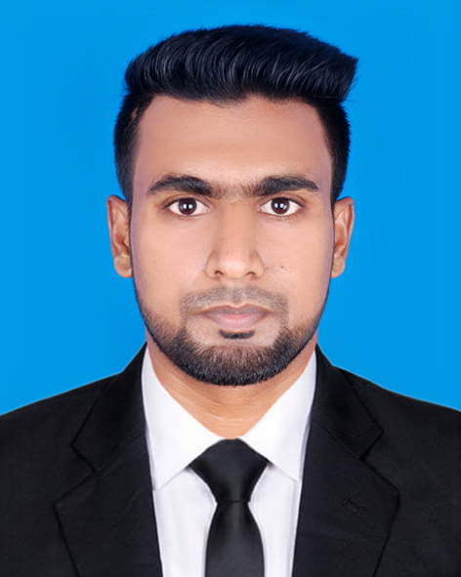
MD. MOHIT HASAN
Address : 56, Shukrabad, Dhaka.
Cell : 01750-520906
Email : mohithasan906@gmail.com

Career Objective
To build up a career in a well-established and environment friendly organization where acquired knowledge and expertise can be used effectively and efficiently.

Skills And Abilities
- Good in oral and written communication.
- Outgoing friendly personality, confident dealing with people.
- Creative and practical.
- Responsible, honest, adaptable and well presented.

Acadamic Qualifications
Bachelor of Business Administration (BBA) Honours

Name of Institute : Dhaka Commerce College.
Main Study Topics : Marketing.
Passing Year : 2019.
Achievement & Result : 3.27 out of 4.
University : National University.

Higher Secondary Certificate (H.S.C)
Institute : Rangpur Government College, Rangpur.
Group : Business Studies.
Passing year : 2015.
Result : 3.83 out of 5.
Board : Dinajpur.

Secondary School Certificate(S.S.C)
School : Bir Uttam Shaheed Samad High School, Rangpur.
Group : Business Studies.
Passing year : 2013.
Result : 4.81 out of 5.
Board : Dinajpur.

IT Skills
I have completed a six-month Computer Application Course from Bangladesh German Technical Training Center.(BGTTC)
- Operating System : Windows 7, Windows 10, MAC OS X
- Application Software : MS Word, MS Excel, MS Power point.
- Others : Internet browsing, E-mail.
JOB EXPERIENCE
Sales-Executive
19 April 2019 to 30 June 2021.
Rodela Crafts.
Job Responsibilities:
1. Achieve growth and hit sales target by creating new customer.
2. Regular market visit to promote Brand visibilities.
3. Meeting daily, weekly, and monthly sales target.
Personal Information:
Father’s Name : Md. Shahjahan
Mother’s Name : Most. Khaleda
Permanent Address : Vill: Dhap, kellaband.
P.O: Uposhahor.
P.S : Sadar, Dist.: Rangpur.
Nationality : Bangladeshi(by birth)
Date of Birth : 22 October 1997.
Marital Status : Unmarried.
Religion : Islam.
Gender : Male.

DECLARATION:
“I CERTIFY THAT ALL INFORMATION STATED IN THIS RESUME IS TRUE AND COMPLETE TO THE BEST OF MY KNOWLEDGE. I AUTHORIZE THAT TO VERIFY THIS INFORMATION PROVIDED IN THIS RESUME.”

………………..
(MD.MOHIT HASAN)

